Phase 2
Smart Expense Tracker Application
Team Name and Logo
Team Name: Code Crafters OHK
Pronunciation: “oh-kay”
Team Members: Hai Huynh, Kaltoum Mai Moussa Chetima, Omar Lorenzo Jimenez
Slogan: Optimize goals, Handle money, Keep track of spending
Logo Idea:


GitHub Repository
Repository Link: https://github.com/haihuynh0808/CS380-Phase-2---Design.git
Description:
A shared GitHub repository will be used for version control. One team member will create the repository and add the other members as collaborators. The team will use Git to manage code changes and ensure collaboration throughout development.
Proposed Features / Functionality
1. User Registration
Allows new users to create an account by entering a username and password. The system stores this information securely in the database and ensures that usernames are unique.
2. User Login
Users enter their username and password. The system validates the credentials against stored data. If correct, the user is granted access to their account; otherwise, an error message is displayed.
3. Logout
Ends the current user session securely and redirects the user back to the login screen.
4. Add Transaction
Allows users to input financial data, including type (income or expense), amount, category, date, and description. The transaction is stored in the database and immediately updates the balance.
5. Edit Transaction
Users can modify existing transaction details such as amount, category, or description. The updated data is saved and reflected in calculations.
6. Delete Transaction
Allows users to remove a selected transaction from the system. The balance is automatically recalculated after deletion.
7. View Transaction History
Displays all transactions associated with the logged-in user. Transactions are sorted by date and can be reviewed for tracking purposes.
8. Balance Display
Shows the user’s current financial balance calculated as:
Balance = Total Income – Total Expenses
9. Category Summary
Displays total spending grouped by category (e.g., food, rent, transportation), helping users understand spending habits.

Stretch Features (Optional)
- Charts and graphs
- Budget alerts
- Savings goals

Database Schema

Table: users
- userId (INT, Primary Key)
- username (VARCHAR)
- password (VARCHAR)

Table: transactions
- id (INT, Primary Key)
- userId (INT, Foreign Key)
- type (VARCHAR)
- amount (DOUBLE)
- category (VARCHAR)
- date (DATE)
- description (VARCHAR)

Sample Database Data (Required)

Users Table
UserId | Username | Password
1 | Omar123 | Pass123
2 | Haih | Pass456

Transactions Table
Field Name | Data Type | Description
id | INT (PK) | Unique identifier
userID | INT (FK) | User ID
type | VARCHAR(10) | Income or Expense
amount | DOUBLE | Transaction amount
category | VARCHAR(50) | Category name
date | DATE | Transaction date
description | VARCHAR(255) | Optional notes

Sample Data
id | UserId | type | amount | category | date | Description
1 | 1 | Income | 2000 | Salary | 2026-04-01 | Monthly pay
2 | 1 | Expense | 500 | Rent | 2026-04-02 | Apil rent
3 | 2 | Expense | 150 | Food | 2026-04-03 | Groceries

UML Class Design
Transaction Class
- id: int
- type: String
- amount: double
- category: String
- date: LocalDate
- description: String
TransactionManager Class
- addTransaction ()
- editTransaction ()
- deleteTransaction ()
- getAllTransactions ()
- calculateBalance ()
- getCategorySummary ()
DatabaseManager Class
- connect ()
- validateLogin ()
- insertUser()
- insertTransaction ()
- updateTransaction ()
- deleteTransaction ()
- fetchTransactions ()
MainUI Class
- displayLoginScreen ()
- displayRegisterScreen ()
- DisplayMainDashboard ()
- displayAddTransactionForm ()
- displayTransactionHistory ()
- displayEditTransactionForm ()
- displayCategorySummary ()
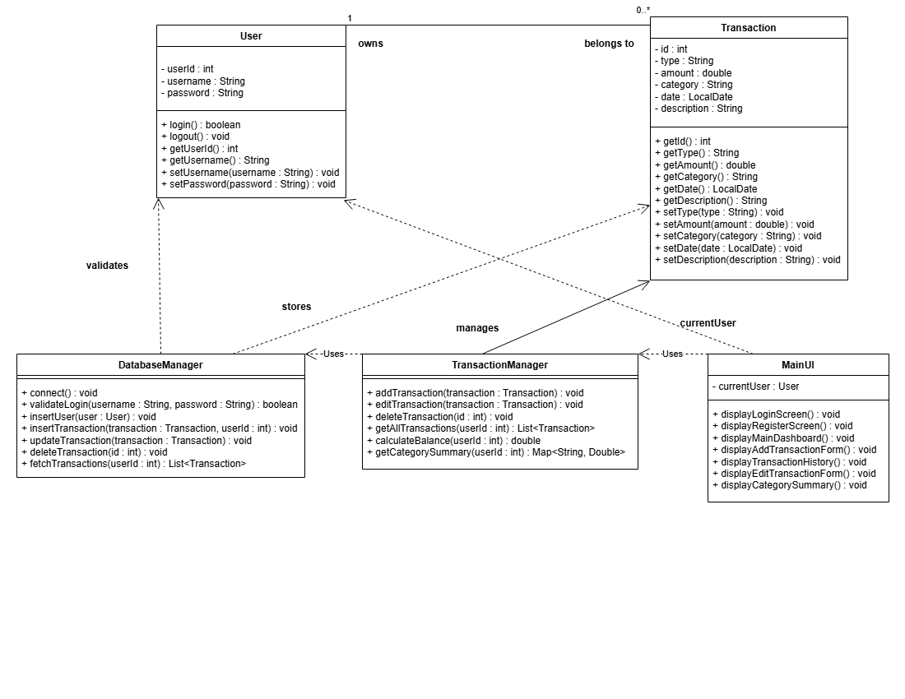

Use Case Diagram
Actor: User
Use Cases:
- Register Account
- Login
- Add Transaction
- Edit Transaction
- Delete Transaction
- View Transactions History
- View Balance
- View Category Summary
- Logout
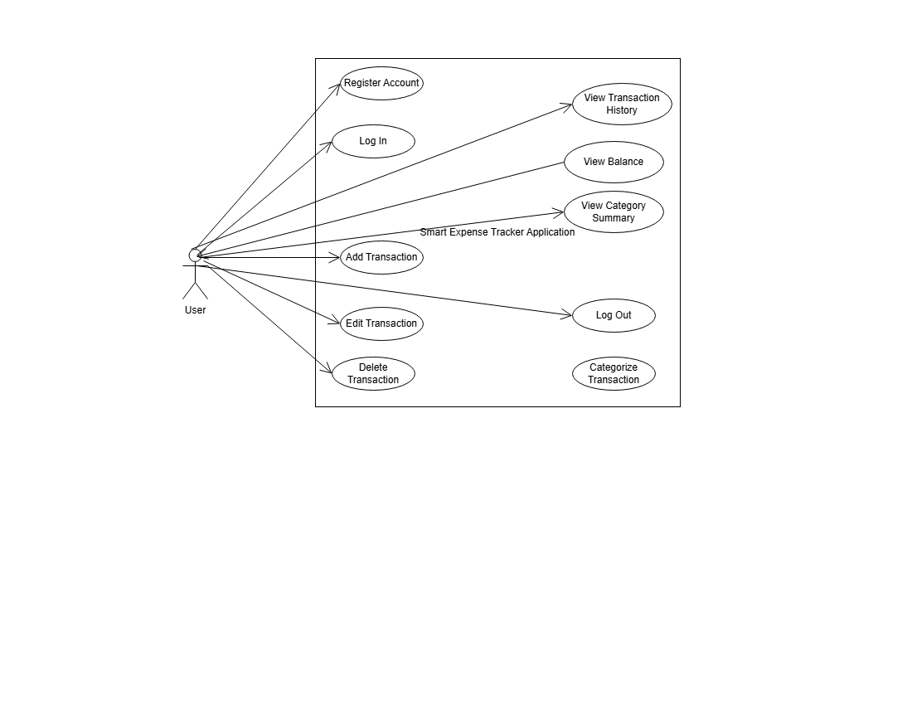

Application Windows

Application Windows
1. Login Screen
Allows users to enter their username and password. The system validates credentials and grants access if correct.
2. Register Screen
Enables new users to create an account by entering a username and password. Includes validation for unique usernames.
3. Main Dashboard
Displays the user’s current balance, a quick summary of transactions, and navigation options to other features.
4. Add Transaction Window
Provides a form where users can input transaction details such as type, amount, category, date, and description.
5. Transaction History Window
Shows a list of all past transactions in chronological order. Users can review their financial activity.
6. Edit Transaction Window
Allows users to update or delete an existing transaction. Changes are saved and reflected immediately.
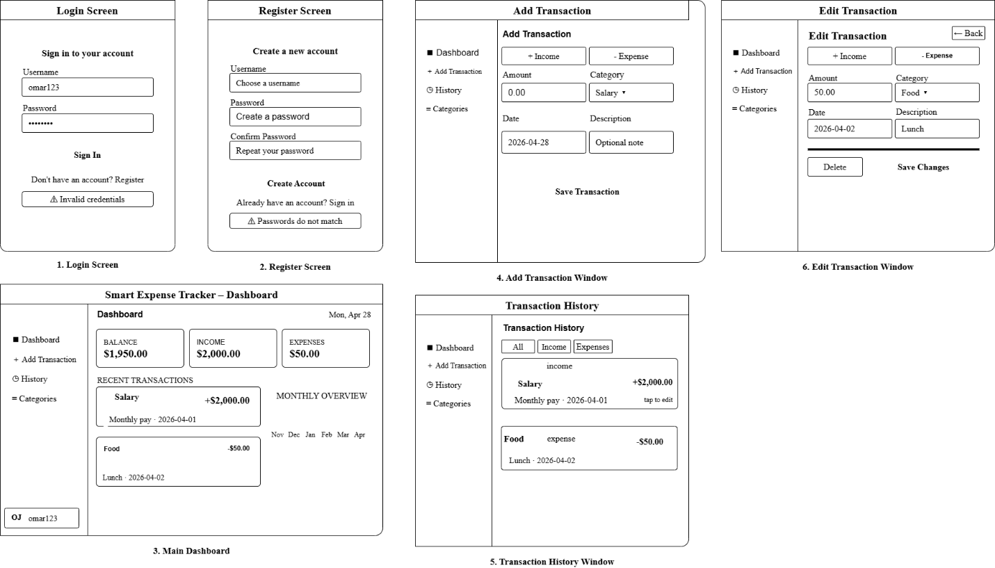

Design Justification
This design follows modular architecture by separating the user interface, business logic, and database management. This improves maintainability and scalability. The system prioritizes core functionality such as transaction tracking and balance calculation, ensuring a strong foundation before adding advanced features. User authentication ensures that each user’s data is securely stored and accessed independently.

